- (Level 3) [LEVEL 2]

You may not know what this is, but there was a man who did.
Hint: Maybe printing it would help

- (Level 3) [LEVEL 3]
Let the catholic priest primarily guide you as le père de l'acoustique
https://drive.google.com/file/d/1MJZB0v8wD8hUMyC0I95xooQgd0iXz5Xh/view?usp=sharing
- (Level 3) [LEVEL 3]

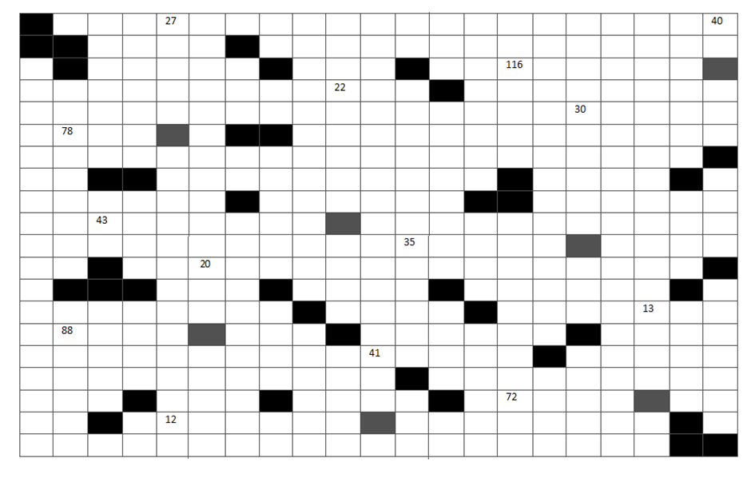
ACROSS:
12. London landmark an Aussie might tell you to visit
20. One waiting at the airport?
22. It can flow or tangle
35. What is the name of Dennis the Menace's dog?
43. Poetic form consisting of 14 lines
69. Person with Chinese Sugondese trait is called
72. The answer (almost but not quite entirely unlike)
78. Why are you gayuessing?
88. Affluent Connecticut town
116. Greek letter; pilot announcement, shortened; itinerary abbreviation

DOWN:
13. Ancestor to the DVD player
20. Inventor Whitney; quarterback_ Manning; Book of Ivy Leaguer
22. This object made it possible to buy salmon for consumption
27. Bud setting; notice; attention; listener; musical sense; big part of an elephant
30. The Italian food gnocchi is made from what
40. Mind find; vein contents; dig it
41. Island in the Caribbean Sea, which forms a federation with Saint Kitts
69. Death, destruction, diarrhea; North and South Korea

- (Level 1) [LEVEL 1]
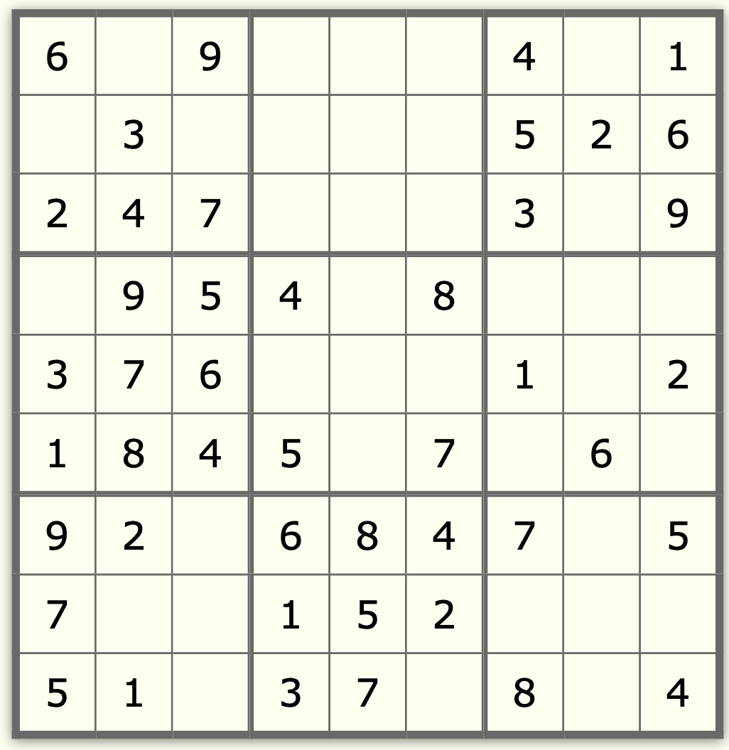
Be rational while solving this.

Hint:

Answer: 227

- 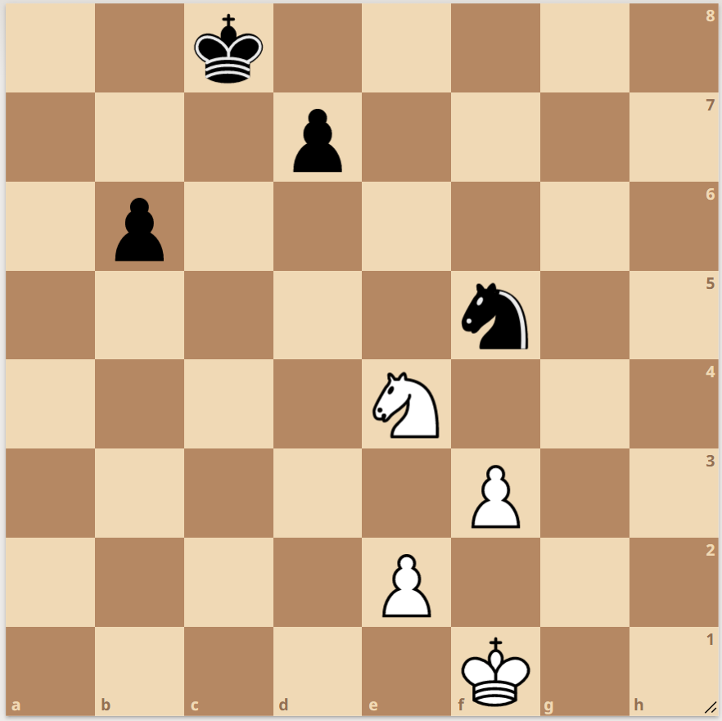

(Level 3) [LEVEL 3]

Now who could’ve played this?

Hint: Note the positions for your ease.

- Level 1 [LEVEL 1] (Could try to make it a bit harder)
- Black background
- Picture of globe
- Coordinates printed on black background in black font at discrete places.
- Locate those coordinates on map {43°58′42″N, 15°23′01″E
- Shows a particular shape
- Password is that SHAPE
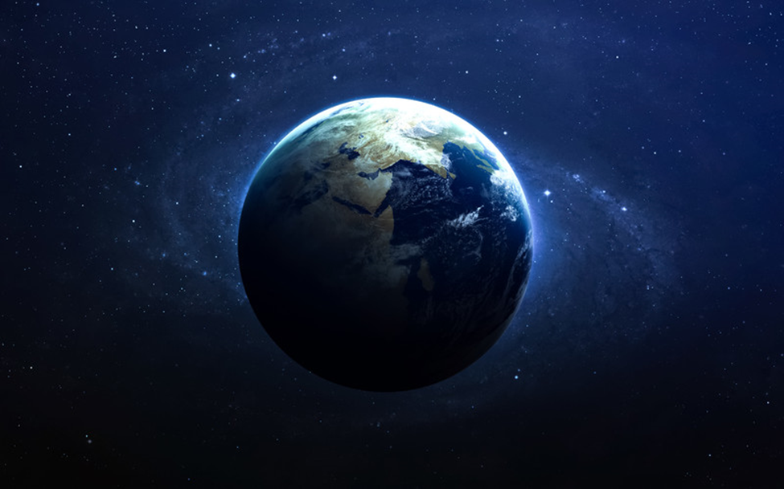

Add this image as background
Add Eratosthenes as a hint
Add 43 . 58 42,
15 . 23 01 either in source code or such that they get hided in background

I recommend inspect element - Aryaman (Akash approves)
Ok bhaiya - Jatin

- Level 2 [LEVEL 2]
- Blank Page with 6 markings (Red Dots)
- Europe written as hint that mark these points on map.
- Take first letters of these cities (Only A-F) from left to right in order
- You get the colour code
- Next an image will be given in source code
- To access that image this hexcode as a password must be entered.
- QR Code in zip file in drive link with password #ACBBAD



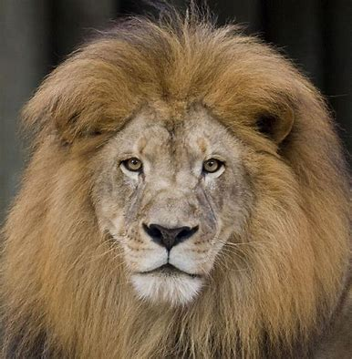
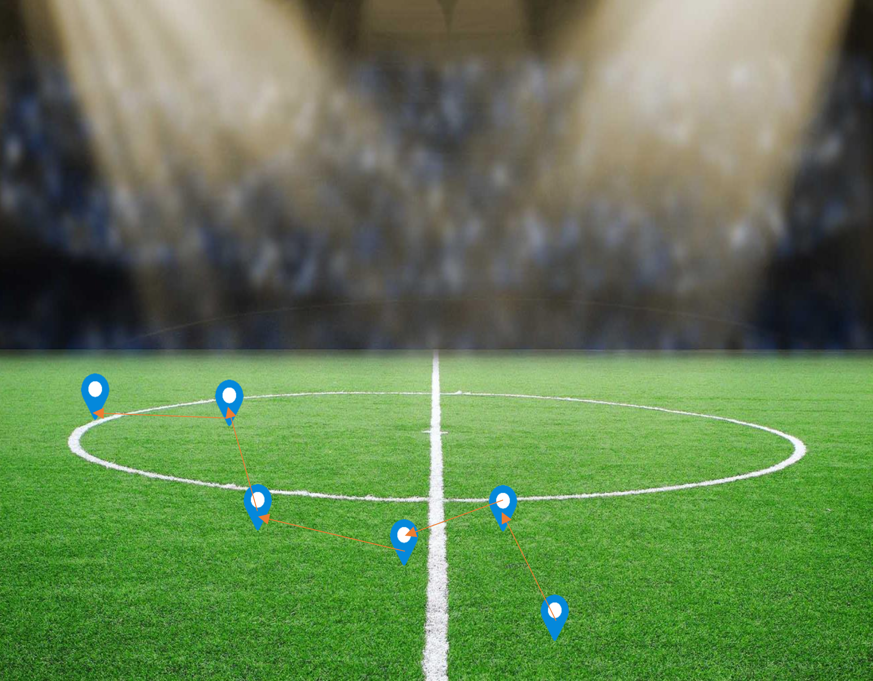
Dublin City F.C
Ankara_Demirspor

Add Dublin City F.C. - Wikipedia as a hyperlink on first ball
Add https://en.wikipedia.org/wiki/ as a hyperlink on last ball

Hex code would be from Right to Left. (given hint by arrows)
Hint of Europe given by Famous football league logos.

Change Colors in a PNG - Online PNG Maker (onlinepngtools.com)
This website can replace a color in an image—
- Click Me prompt with below google drive link.

https://drive.google.com/file/d/1KNECkCSTqi7PWclAGdvh6QakHHExgi42/view?usp=sharing

- Thermopylae [LEVEL 1]
Want this image as hint toward the painter of same (https://en.wikipedia.org/wiki/The_Death_of_Socrates )
Spartan war cry (aho aho ) : audio clip that is clickable
Old map of Sparta and asia minor ( to show war )
Oracle of delphis prophecy ( I want pic of Delphi which open through link )
O ye men who dwell in the streets of broad Lacedaemon!
Either your glorious town shall be sacked by the children of Perseus,
Or, in exchange, must all through the whole Laconian country
Mourn for the loss of a king, descendant of great Heracles.

Ω άντρες που κατοικείτε στους δρόμους της πλατιάς Λακεδαίμονος!
Είτε η ένδοξη πόλη σας θα λεηλατηθεί από τα παιδιά του Περσέα,
Ή, σε αντάλλαγμα, πρέπει σε όλη τη Λακωνική χώρα

Πένθος για την απώλεια ενός βασιλιά, απόγονου του μεγάλου Ηρακλή.
Background (https://upload.wikimedia.org/wikipedia/commons/thumb/9/9e/Kaulbach%2C_Wilhelm_von_-_Die_Seeschlacht_bei_Salamis_-_1868.JPG/300px-Kaulbach%2C_Wilhelm_von_-_Die_Seeschlacht_bei_Salamis_-_1868.JPG) it must have clickable link
And link to image of gates of hell
- Second [LEVEL 1]
Gleipnir
It is made up of this so want them in as hint
- The sound of a cat's footfall
- The beard of a woman
- The roots of a mountain
- The sinews of a bear
- The breath of a fish
- The spittle of a bird
OR TO MAKE IT EASY
• ᛏᚺᛖ ᛋᛟᚢᚾᛞ ᛟᚠ ᚨ ᚲᚨᛏ'ᛋ ᚠᛟᛟᛏᚠᚨᛚᛚ
• ᛏᚺᛖ ᛒᛖᚨᚱᛞ ᛟᚠ ᚨ ᚹᛟᛗᚨᚾ
• ᛏᚺᛖ ᚱᛟᛟᛏᛋ ᛟᚠ ᚨ ᛗᛟᚢᚾᛏᚨᛁᚾ
• ᛏᚺᛖ ᛋᛁᚾᛖᚹᛋ ᛟᚠ ᚨ ᛒᛖᚨᚱ
• ᛏᚺᛖ ᛒᚱᛖᚨᛏᚺ ᛟᚠ ᚨ ᚠᛁᛋᚺ
• ᛏᚺᛖ ᛋᛈᛁᛏᛏᛚᛖ ᛟᚠ ᚨ ᛒᛁᚱᛞ

Want HPYERLINK THAT GOES TO THIS IMAGE

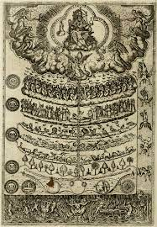
Background :- (https://upload.wikimedia.org/wikipedia/commons/thumb/b/b5/Great_Chain_of_Being_2.png/300px-Great_Chain_of_Being_2.png)

Want this image as water mark 

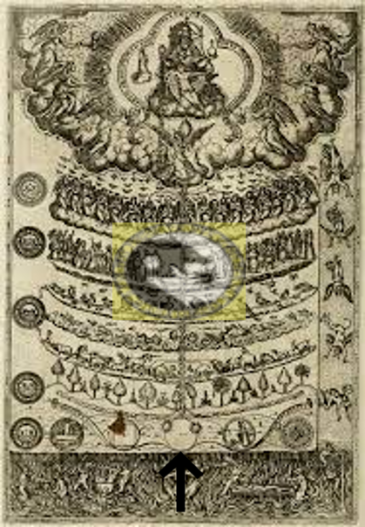

- THIRD [Not going]
Miyamoto musashi
Background ( https://rare-gallery.com/thumbs/4549233-warrior-samurai-total-war-shogun-2-video-games-sword-reflection.jpg)
Water mark of this image (https://en.wikipedia.org/wiki/File:Hidari_mitsudomoe.svg )
Image link leading to picture(https://i.pinimg.com/736x/d3/29/7c/d3297c4308e34ff312f9fe730c7eed43--book-of-five-rings-japanese-history.jpg )
image leading hinting famous painting of musashi (https://encrypted-tbn0.gstatic.com/images?q=tbn:ANd9GcSbxRAkgC9d6y5Kmlcjs5W2MUUp30JOpOS4Rg&usqp=CAU )

the island were the greatest duel of warring state happened (https://kanmon.gr.jp/kanmon2020/img/uploads/up_2387_name.jpg )
- Fourth
Cosmo
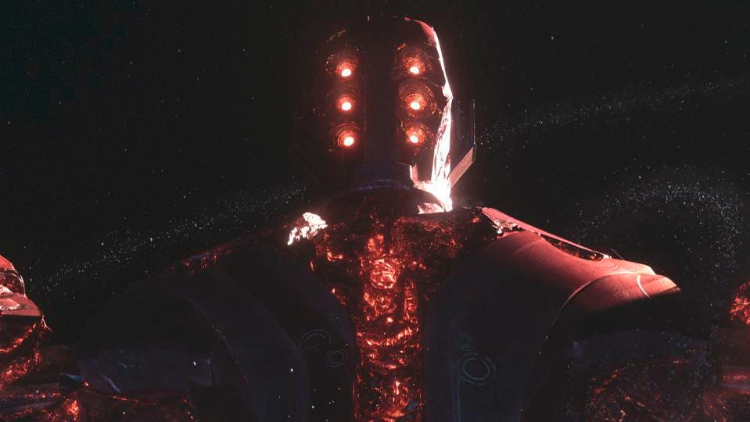

Background image

I don't belong here but now this is home I guard
To be written on the celestial head
(⟟ ⎅⍜⋏'⏁ ⏚⟒⌰⍜⋏☌ ⊑⟒⍀⟒ ⏚⎍⏁ ⋏⍜⍙ ⏁⊑⟟⌇ ⟟⌇ ⊑⍜⋔⟒ ⟟ ☌⎍⏃⍀⎅)
Link to image of must inside this word ( ⟒⏃⍀⏁⊑ )

- Not going
FIFTH
tutankhamun
background
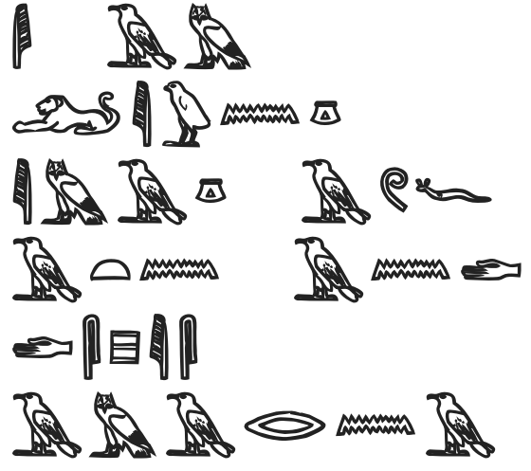
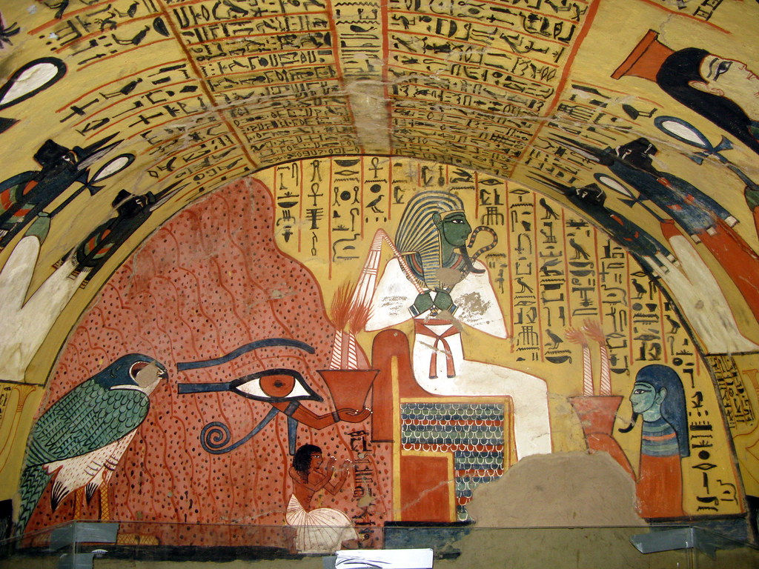
I am living image of Aten and despise amarna
want this written over the image
m several strains of the parasite, in

- Not going unless modified.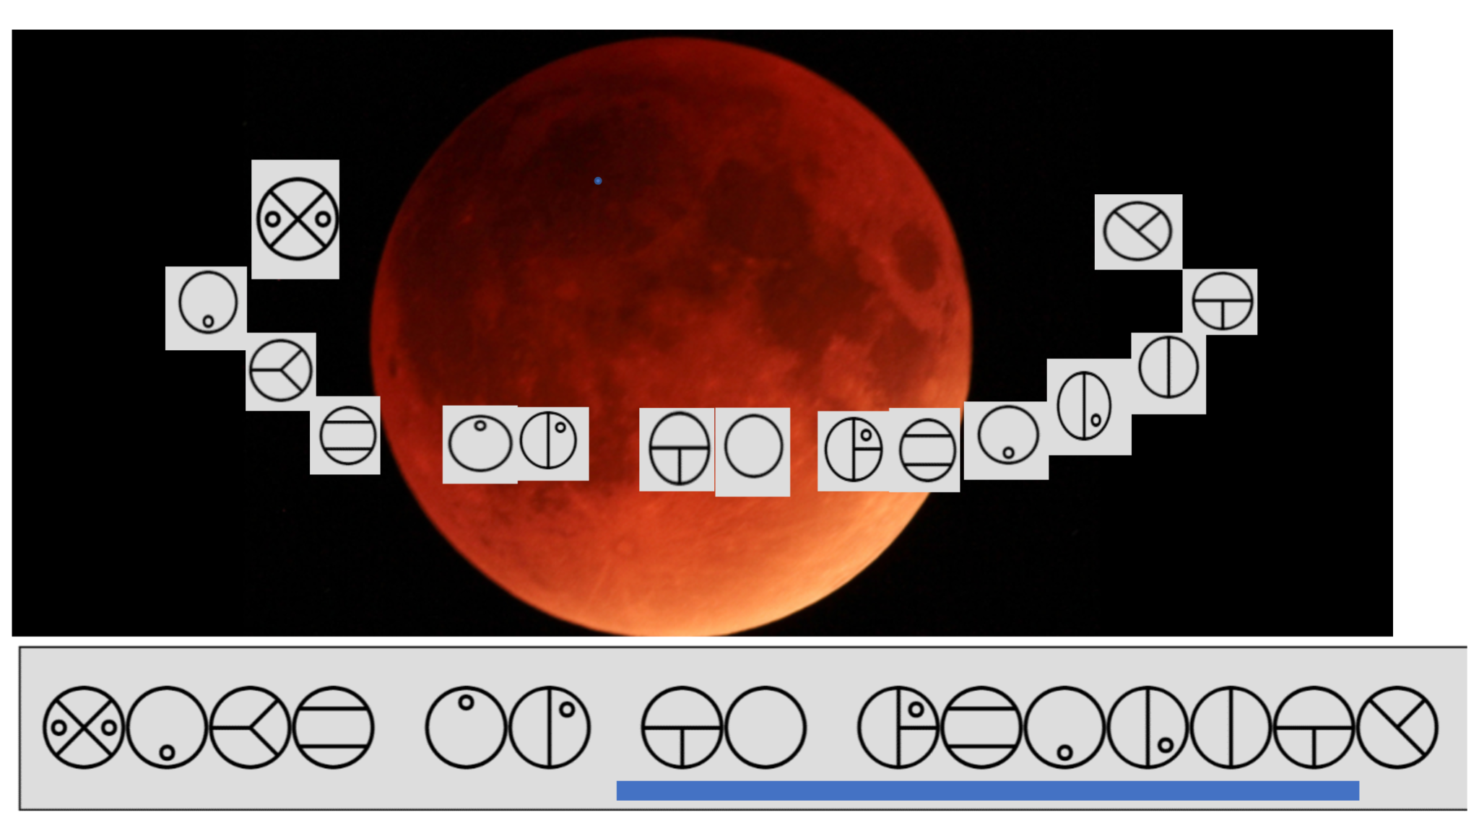
Ans - “uchihamadara”

[LEVEL 2]


I won’t see the Milky Way this year…
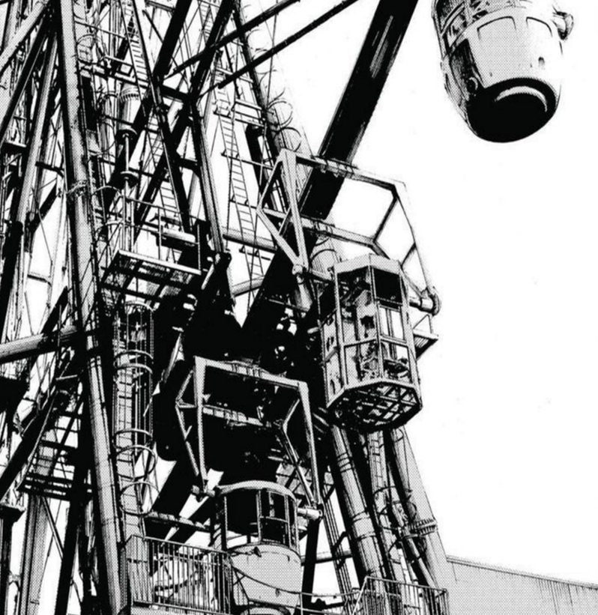
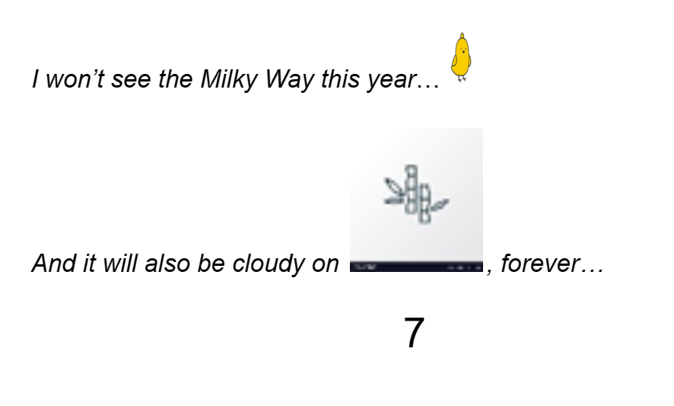
And it will also be cloudy on , forever…
7

// All dialogue in Japanese
// In place of <i> put:

// Instead of the word Tanabata,
Put the following image:
Also make this image clickable and link to the following image:

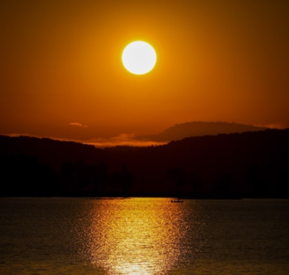
/*Write 7 in the middle of the sun {Hint is that this picture should imply the phrase “Evening of the Seventh” which means Tanabata.*/

Answer: Oyasumi Punpun/ Inio Asano - inioasano

- [LEVEL 1]
Hints:-
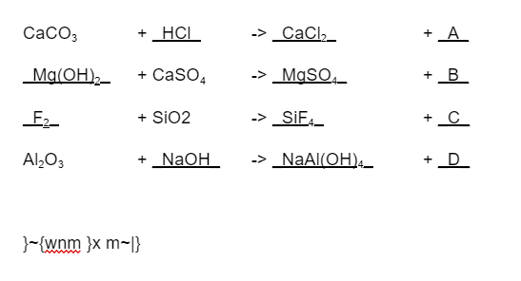

Ans - "apexceyane"

- [LEVEL 1]
(something to indicate click on australia)
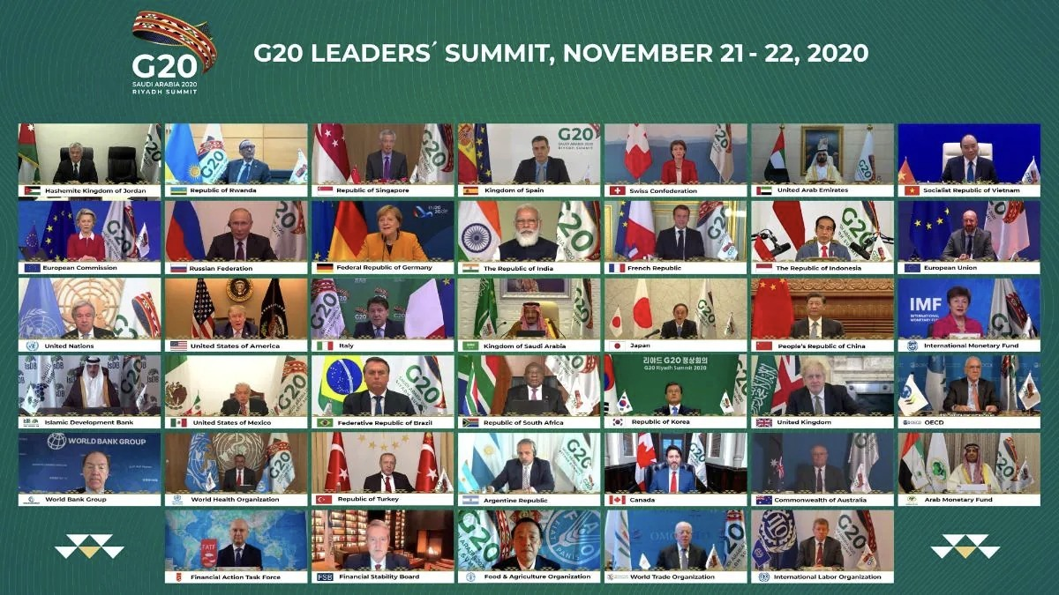
Add hyperlink of next image on commonwealth of australia
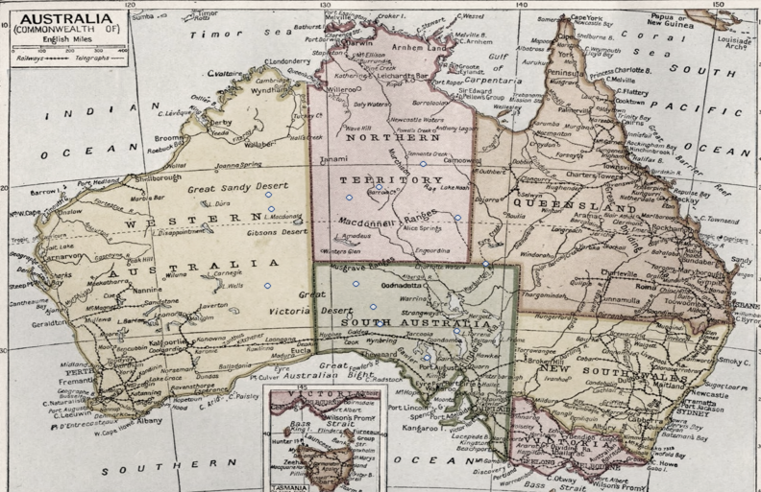
Ans: Pegasus
17. (Level 2) [LEVEL 2]
K, 1, 8, K, 9, J, 8, 2, 1
13, 1, 8, 13, 9, 11, 8, 2, 1
1, 2, 3, 4, 5, 6, 7, 8, 9, 10, J, Q, K
0.69

****Hint for cards required
//Temp - “You might want to practice for your Diwali night”
Ans - “dogecoin”
18. [LEVEL 2]
Process :-
courage -> Degaruoc -> 74107109103120123117105 -> FB15A BC34F EFFDF 3E31_
FbE3 -> https://www.youtube.com/watch?v=Fbe3-wIs7rU -> shorturl.at/dAFL4
BcFe -> https://www.youtube.com/watch?v=BCfE-eIy354 -> shorturl.at/cGKV4
13F3 -> https://www.youtube.com/watch?v=13f3-IWWK2c-> shorturl.at/iAFVX
54D1 -> https://www.youtube.com/watch?v=54d1s-spFvw -> shorturl.at/aCEG2
AfF_ -> https://www.youtube.com/watch?v=aff-GqjmJOk -> shorturl.at/aBDK5

Hints :- (order maintained)
shorturl.at/dAFL4
shorturl.at/cGKV4
shorturl.at/iAFVX
shorturl.at/aCEG2
shorturl.at/aBDK5
Hint : why dont you equally store four?
Broaden your perspective to the four dimensions
Ans - “cowardlydog”

19. Reflection/Mirrors
[LEVEL 3]
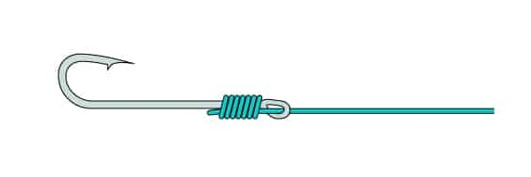

**IMP - Change background on the following photo to #F7F7F7 or rgb(247, 247, 247)**
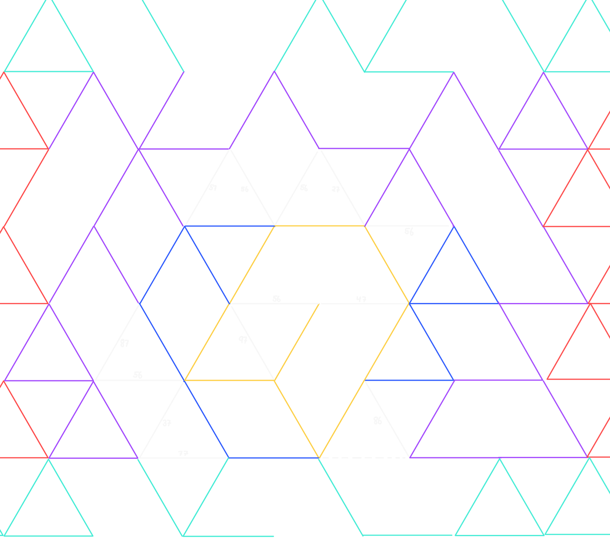

20. Song visualiser one
[LEVEL 3] (mostly)

Final hint:
Lying in the depths of the dark
Lays the one who made my heart her mark

Answer: Kaori
21. What if the cards played you? [LEVEL 1]
[Hint: Some kings are jokers]

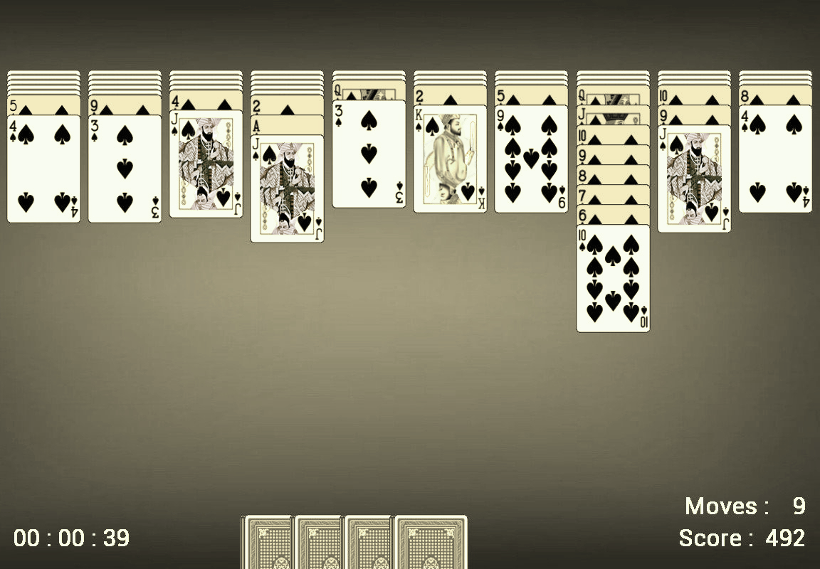
Answer: khurasan

22. [Level 1]
Ques :-

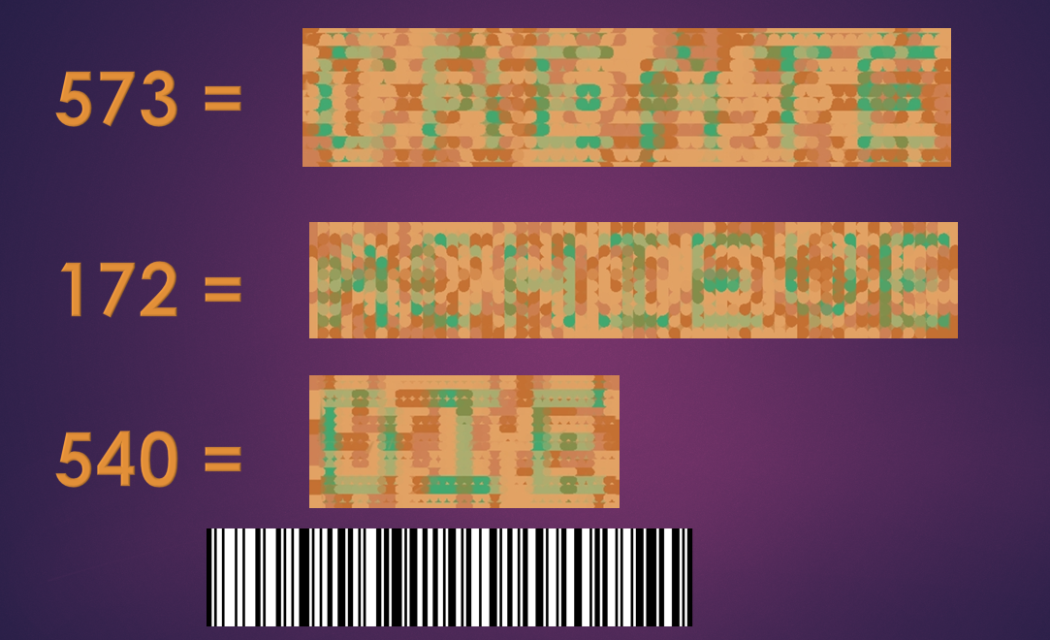
Hint :- 404. If you don’t get it, click here (bit.ly/3Jgc8tQ)
Ans - “georgedavidson”
23.
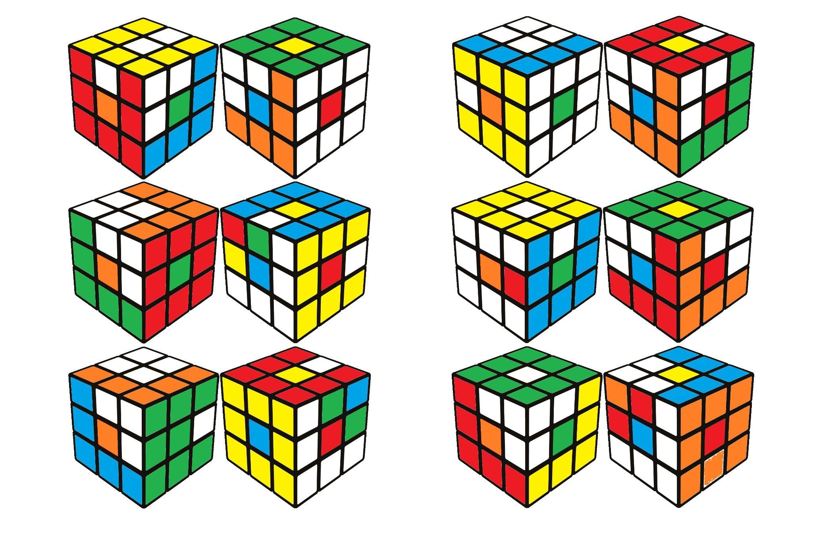
- 6 cubes with different hex codes in form of pigpen ciphers ( these ciphers contain mirror and water images in first 6 letters itself )
- 1 picture showing the order in which they must be read then adding all the colors as hex codes and finally converting, the finally got hex code to decimal to get password
https://www.boxentriq.com/code-breaking/pigpen-cipher
- Cubes showing side view and they may get confused while unfolding the cube
- Lines in between give the hint of adding (as in form of +)
HEXCODES -
- FBAEAE
- ACEDAF
- CCFFEC
- CDEFAA
- EFBEAC
- ECAAAE

24. (Level 3)
https://drive.google.com/file/d/1ZTy8iG13MlqoDrWKuoLLZcOGJ2m1sTNV/view?usp=sharing
Are the digits single or in a relationship?
4, 1
1, 1
1, 1
4, 1
3, 1
6, 2
5, 2
5, 2
4, 1
2, 1
1, 1
6, 2
4, 1
4, 2
5, 2
3, 1
1, 1
4, 1
2, 1
2, 1
2, 1
1, 1
1, 1
4, 1
4, 2
3, 1
3, 1
2, 1
2, 1
2, 1
3, 1
2, 1
4, 1
1, 1
4, 2
3, 1
3, 1
3, 1
4, 1

Hint: I like using multiple number systems.

25.
Process :- 1) -> Link to big bang theory
2) -> Link to 2004
3) -> “Did you miss me” in dancing man font
Ques :-
A theoretical physicist failed in college and a neuroscientist had a PhD in hand.
http://bit.ly/3kGtQwz
2)

3)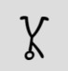 (gif file)
Ans - “jamesmoriarty”

26
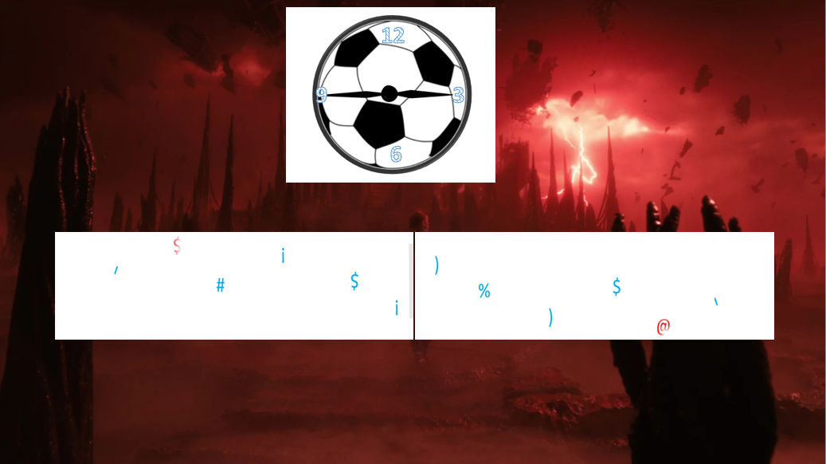
Ans:904
Rotate image, remove background then overlap over one another

27.
Ans - “baldwinI”
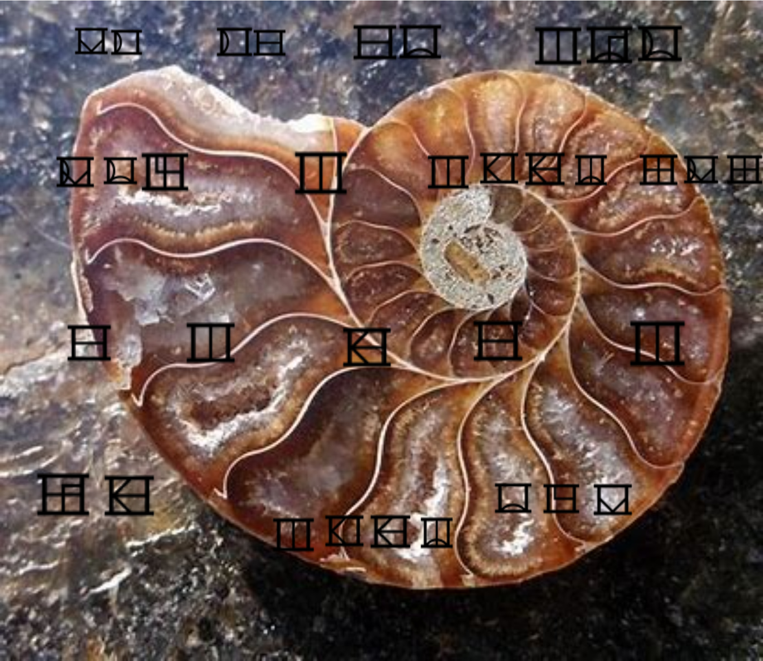
//This photo leads to a link which goes to next image
//If maze does not work replace it with next one

Option 1: (required in high res)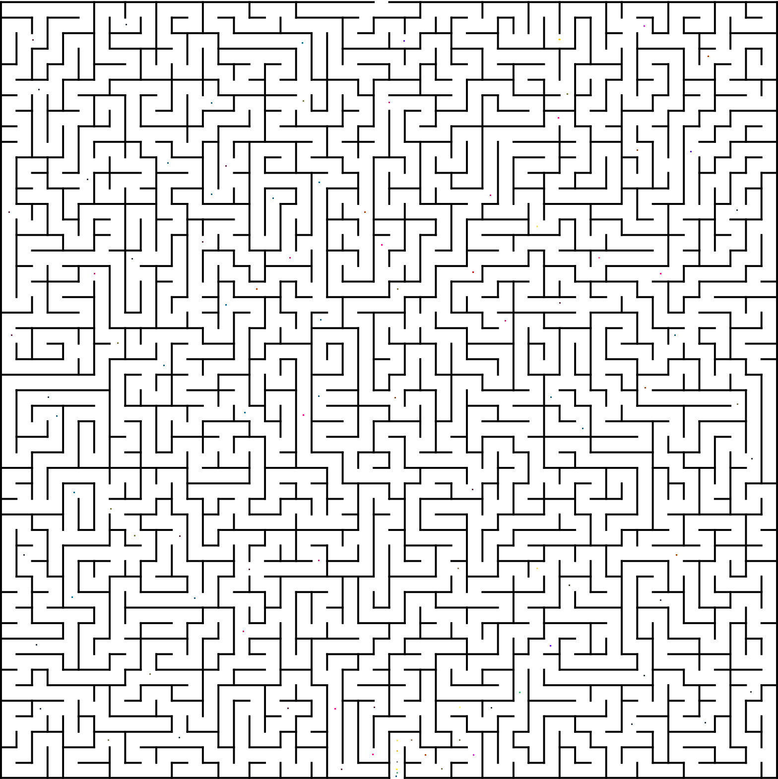
Option 2:
//background:
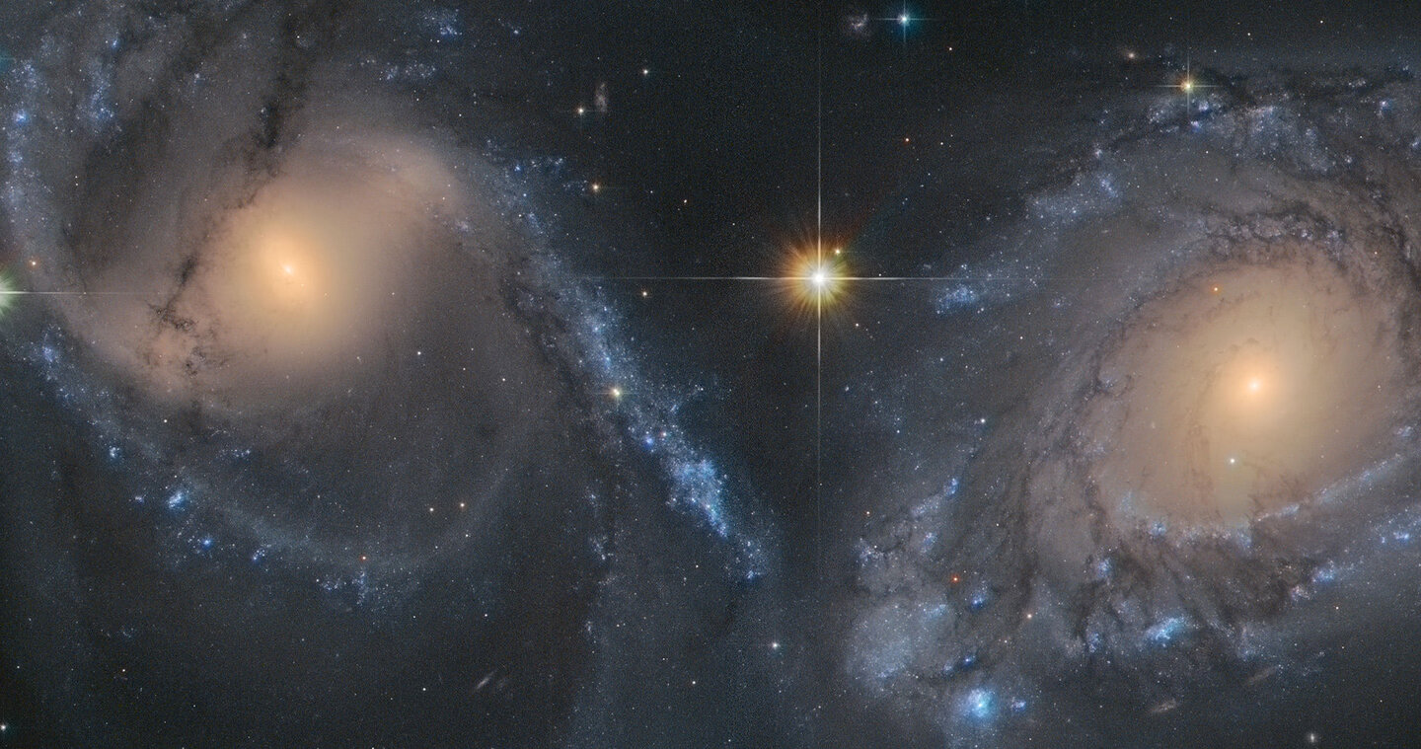

// Text :
| r = 0.0069 { 30 <= theta <= 330 } |= x/sqrt(3) { 0 <= x <= 0.0069*0.8660 }
An infamous maximal equation…
Hints :-
Such equation can turn an evil tetartagonist into good by the power of Love…
Answer : “dojoquest”

